LightHouse Tactile Map Resources

TMAP: Tactile Maps Automated Production
- The place to create your FREE TMAP user-account.
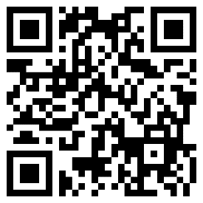
tmap.lighthouse-sf.org/users/sign_in
- YouTube videos:
  - A brief overview of TMAP.
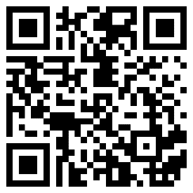
https://www.youtube.com/watch?v=g5QuyCeEs1M

  - Reading a TMAP.
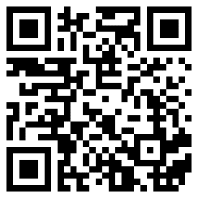
https://www.youtube.com/watch?v=J3t3QHuHlcY

- The resource for everything TMAP.
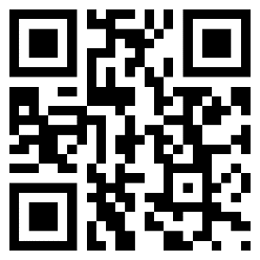
lighthouse-sf.org/tmap

- Email inquiries: tmap@lighthouse-sf.org

Adaptations Store
Adaptations is your online go-to for unique tactile maps not found in other catalogs.
(888) 400-8933
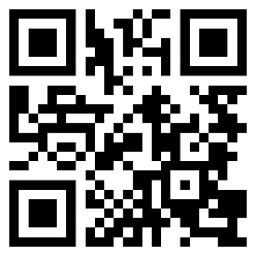
http://adaptations.org

Email inquiries: adaptations@lighthouse-sf.org

MAD Lab (Media and Accessible Design Laboratory)
We specialize in the creation of tactile maps of all types. If you’re in need of a map, contact us.
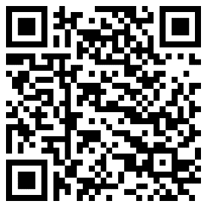
lighthouse-sf.org/braille-and-accessible-design

Email inquiries: madlab@lighthouse-sf.org

BART Maps
If you live or teach in the San Francisco Bay Area, you are eligible to request free tactile maps of BART stations and the Salesforce Transit
- BART Map Request Form

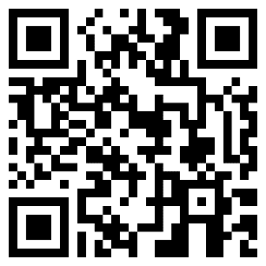
https://forms.office.com/r/be3R1jK6Vz

Jerry Kuns, Consultant
Phone: (415) 793-5673
Email: jerrykuns@gmail.com

